Cloud Computing Laboratory 2 Report

GROUP:6

Members of the Group:

DEVI ABHISESHU ADURTI

## GOVARDHAN ARIKATLA

## GOWTHAM KUMAR SANDAKA

## ARAVINDA SAI DINDI

## Laboratory 2 is composed of three tasks

## 1.Setup and run an Amazon EC2 instance

## 2.Monitoring the performance of an EC2 instance while under CPU and disk pressure.

## 3.Connecting two VMs in (VPC) and monitor the performance while the instance is under web requests pressure.

## Task1: Setting up the VPC and Security groups and run the virtual machines in VPC

## 1. The arrangement of your security group and VPC. You must stimulate for your arrangement choices.

**VPC:**

Here we are creating our VPC with the IPv4 block of 10.0.0.0/16

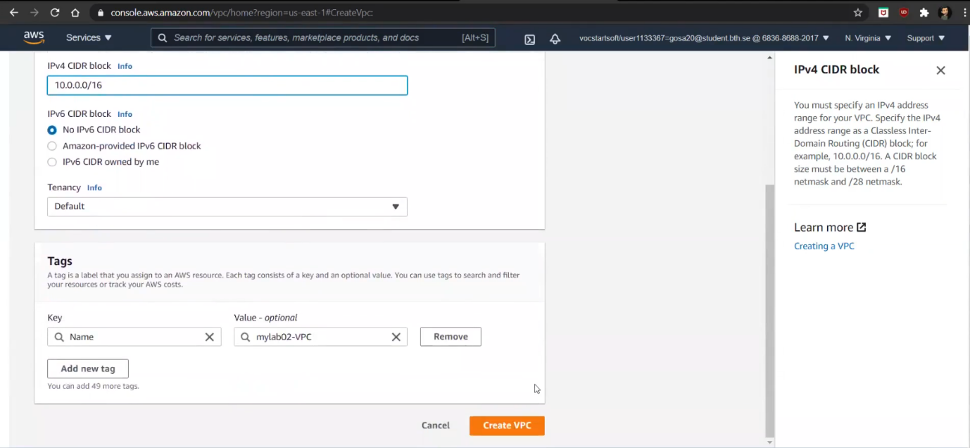

Here our VPC is created successfully

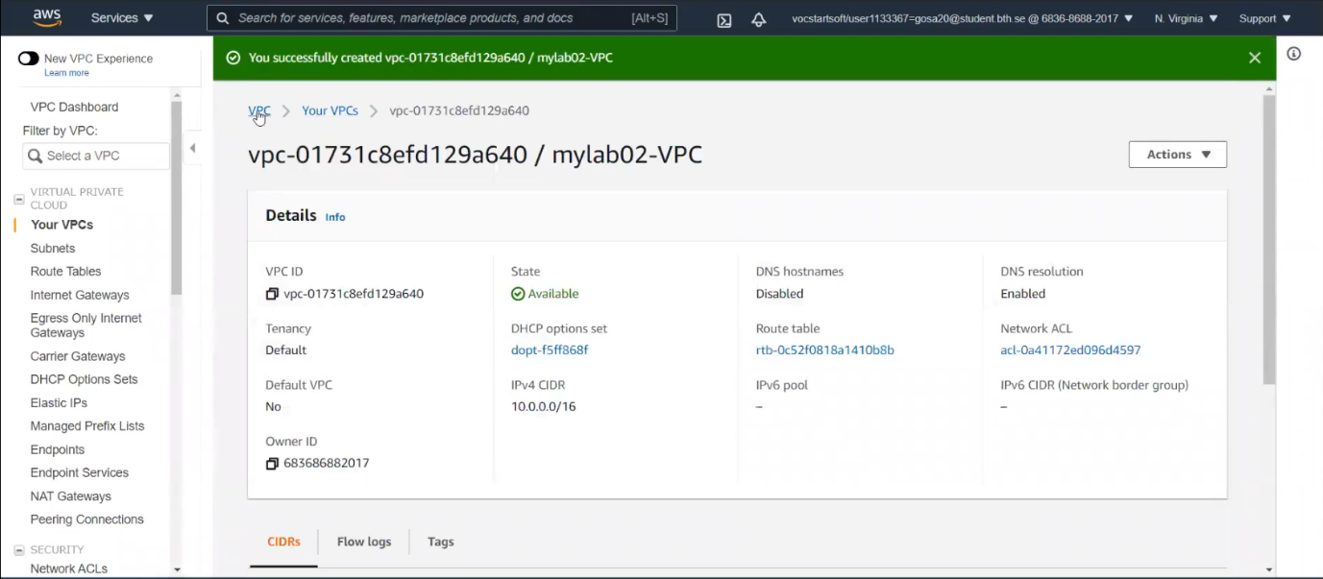

Here you must enable the DNS hostname to your VPC

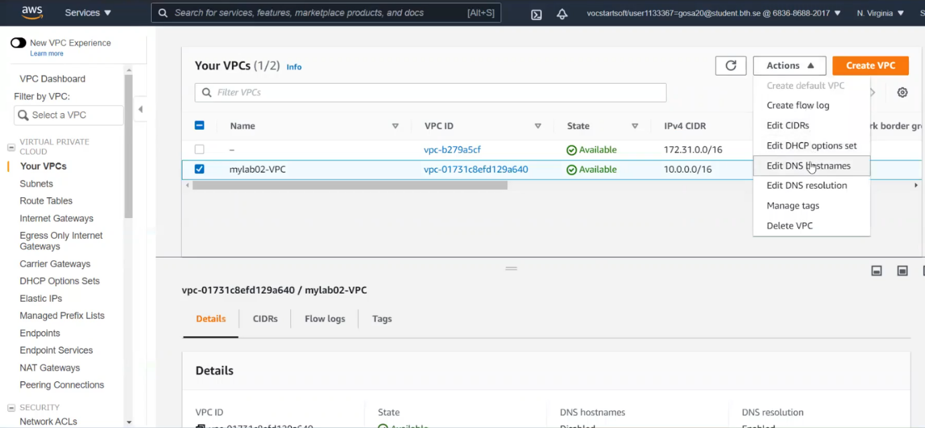

Here the DNS host name is enabled successfully

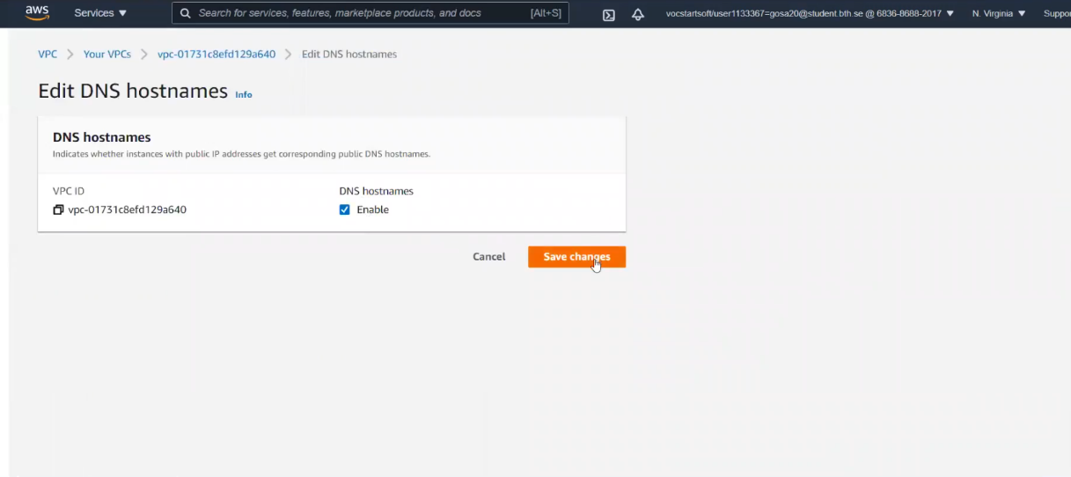

**Security Group:**

Here we are creating our security group

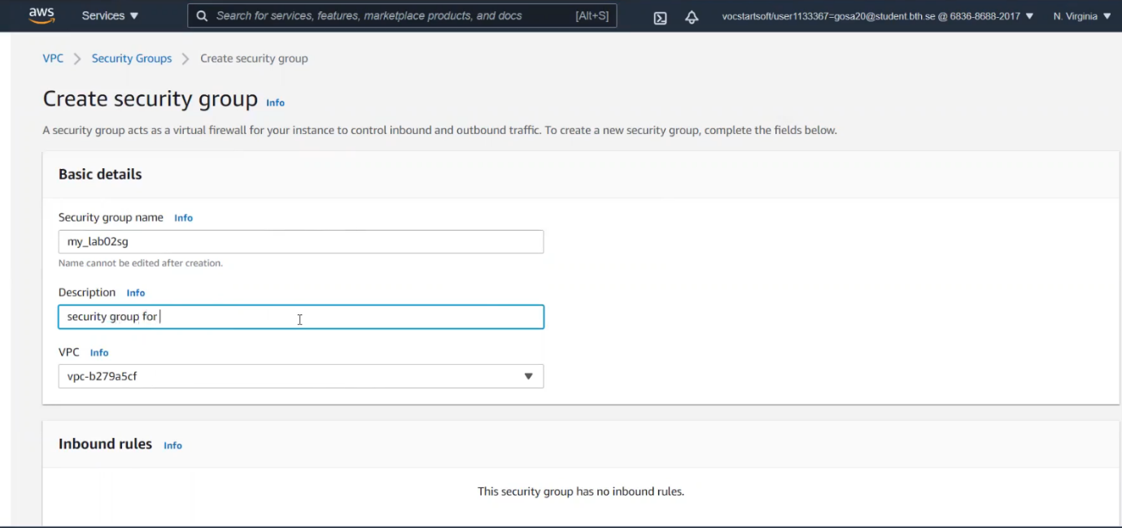

Here we are adding the Inbound and Outbound rules to the security groups

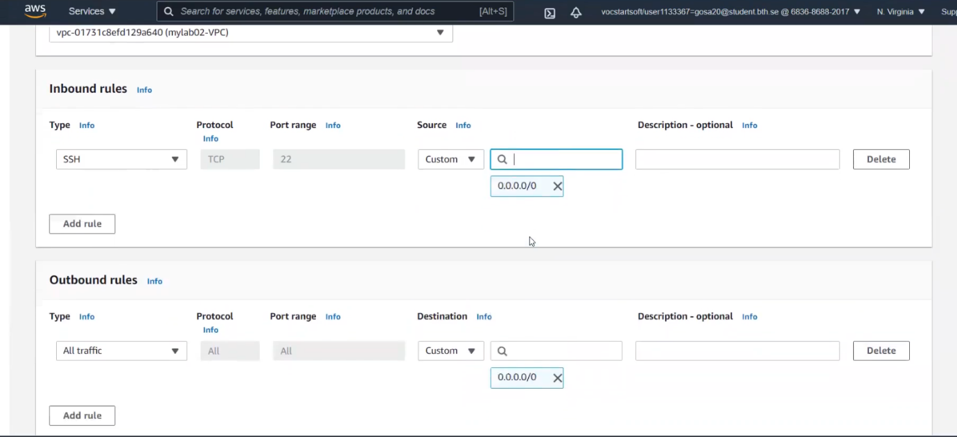

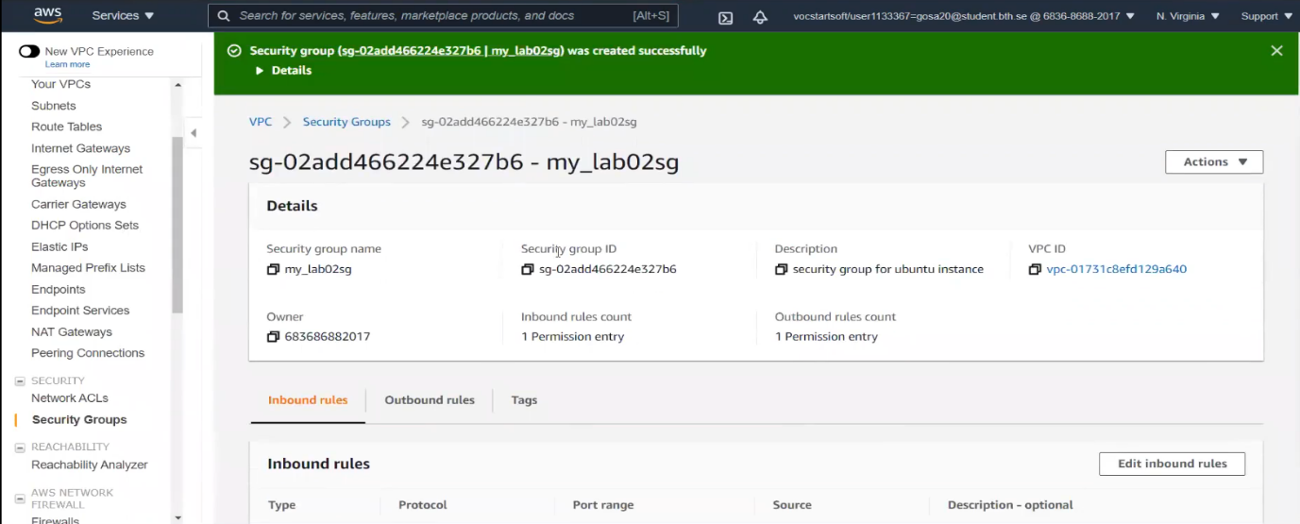

**Creating the Internet Gateway:**

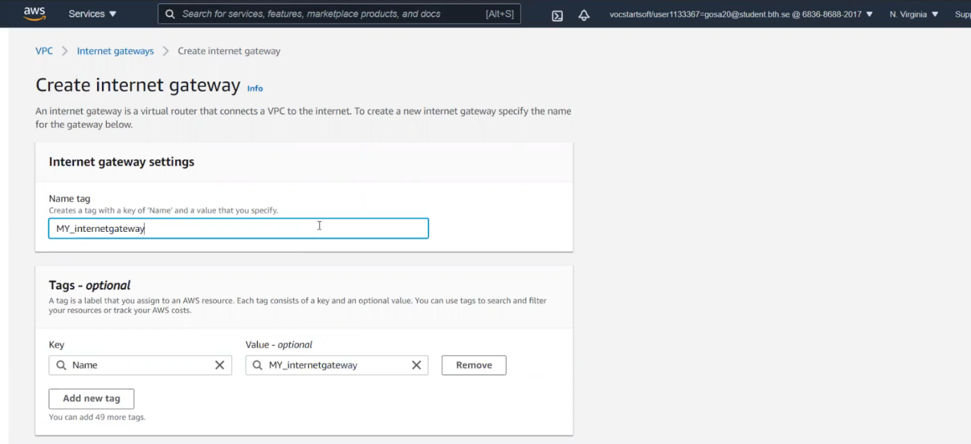

Attach the Internet gateway to our VPC

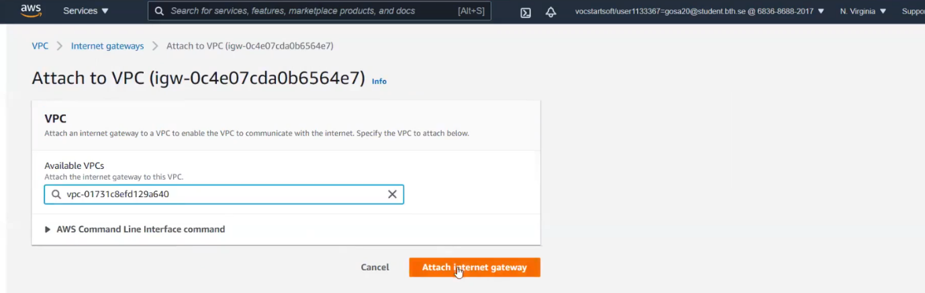

**Creating the Subnets to the VPC:**

1. Here we are creating the public and private subnets

Creating the public subnet to the VPC with the IPv4 block of 10.0.1.0/24. Here you can stimulate the availability zone for the arrangement choices.

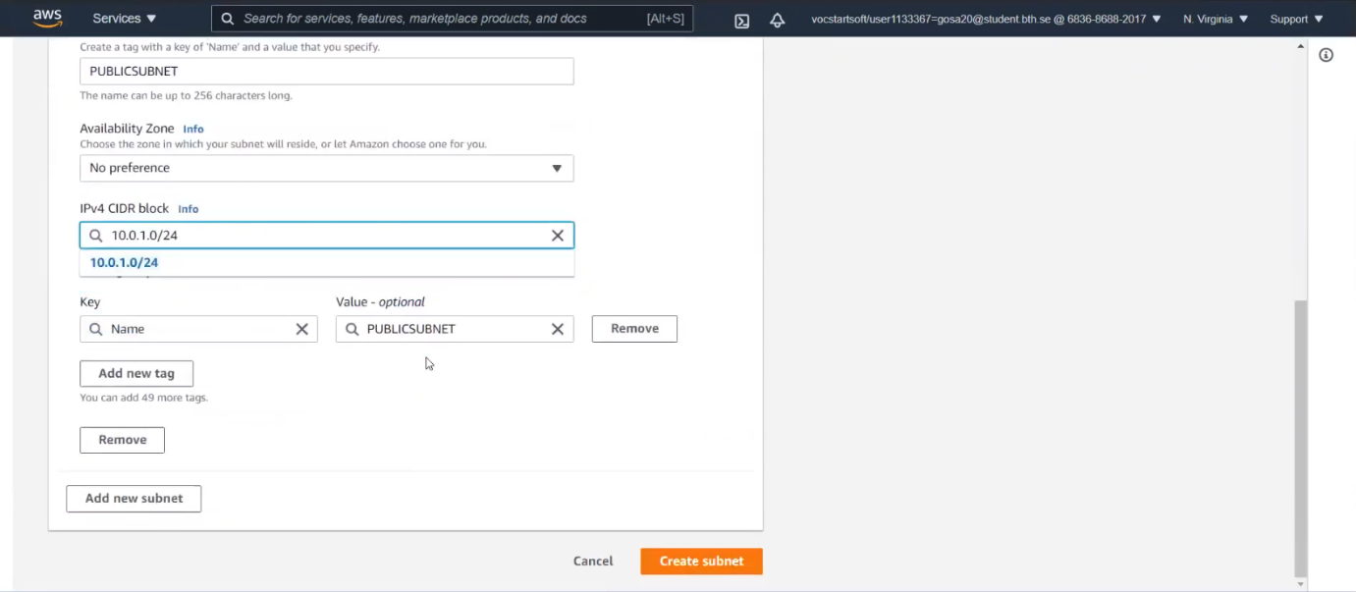

Creating the private subnet to the VPC with the IPv4 block of 10.0.2.0/24.

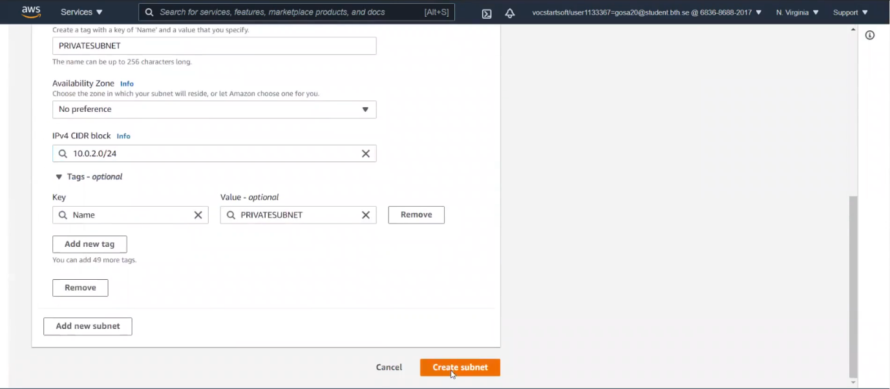

**Creating the Route table to the VPC:**

1. Here we are creating the public and private route tables

Creating the public route table to the VPC

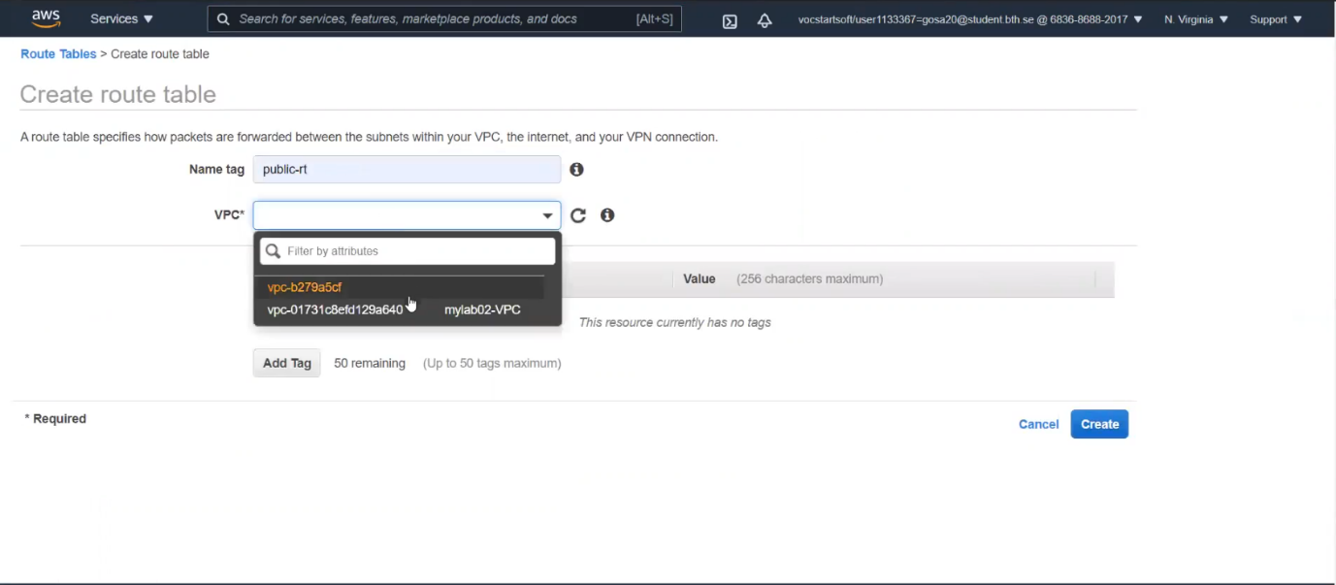

Creating the private route table to the VPC.

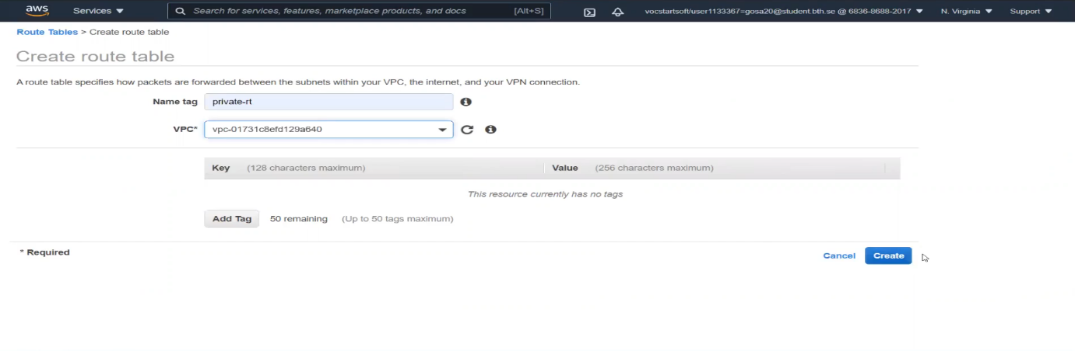

**Associate the Internet gateway and subnets to the routing tables:**

1. Associate the internet gateways to public route table

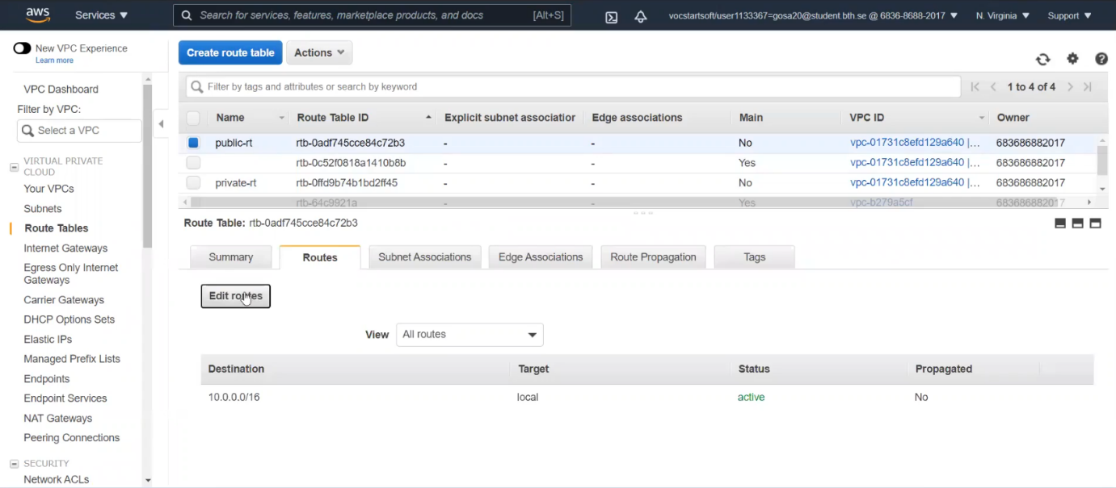

Here the internet gateway is associated successfully

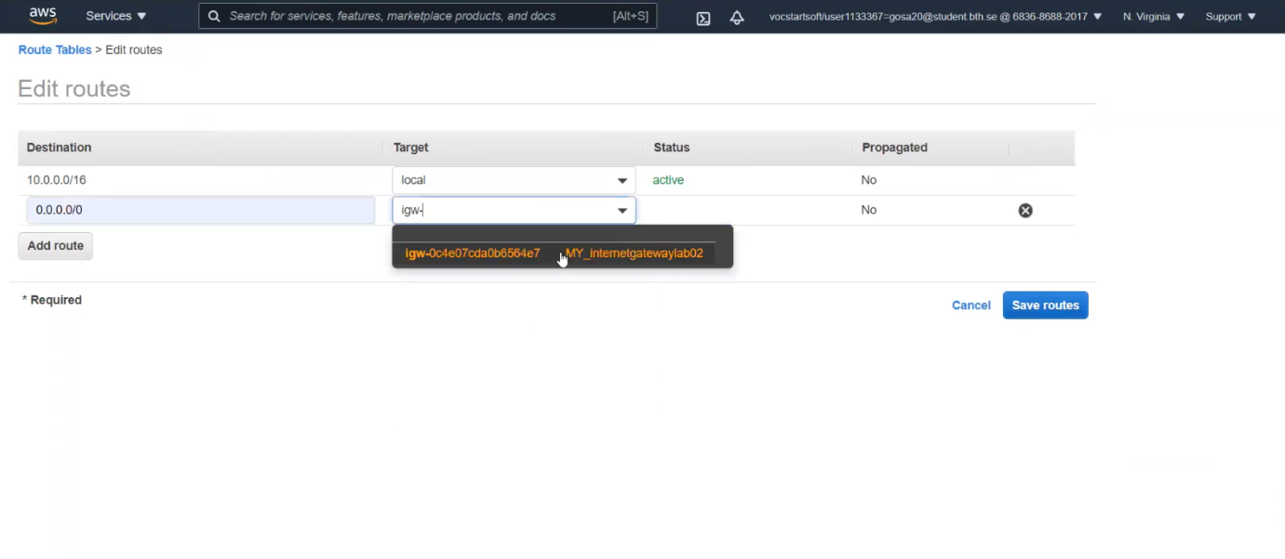

1. Associate the subnets to each routing tables.

Here Associate the public subnet to the public route table.

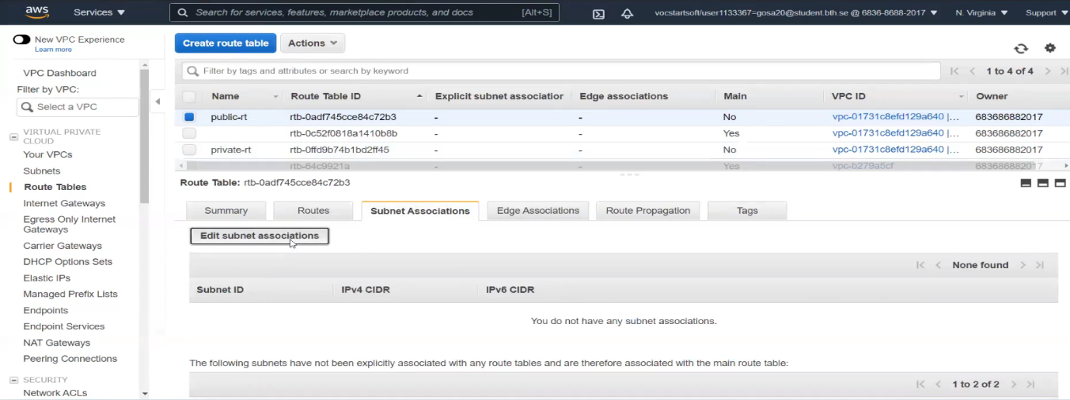

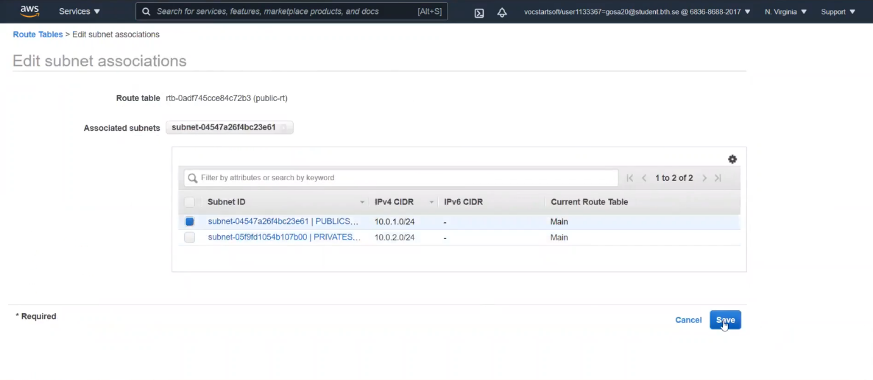

Here Associate the private subnet to the private route table.

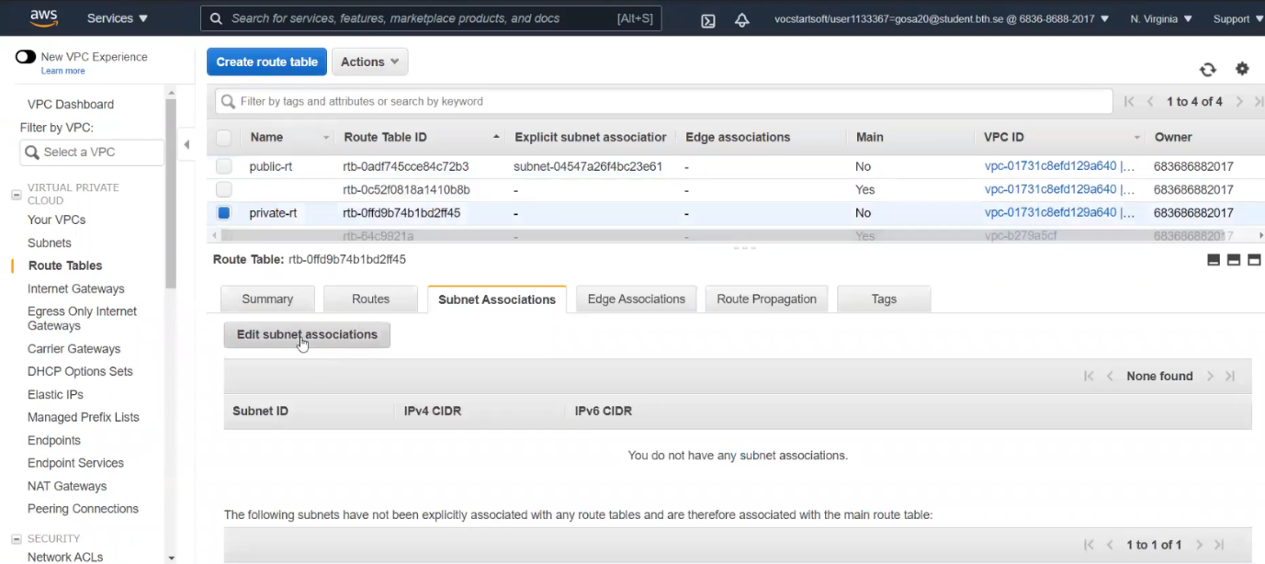

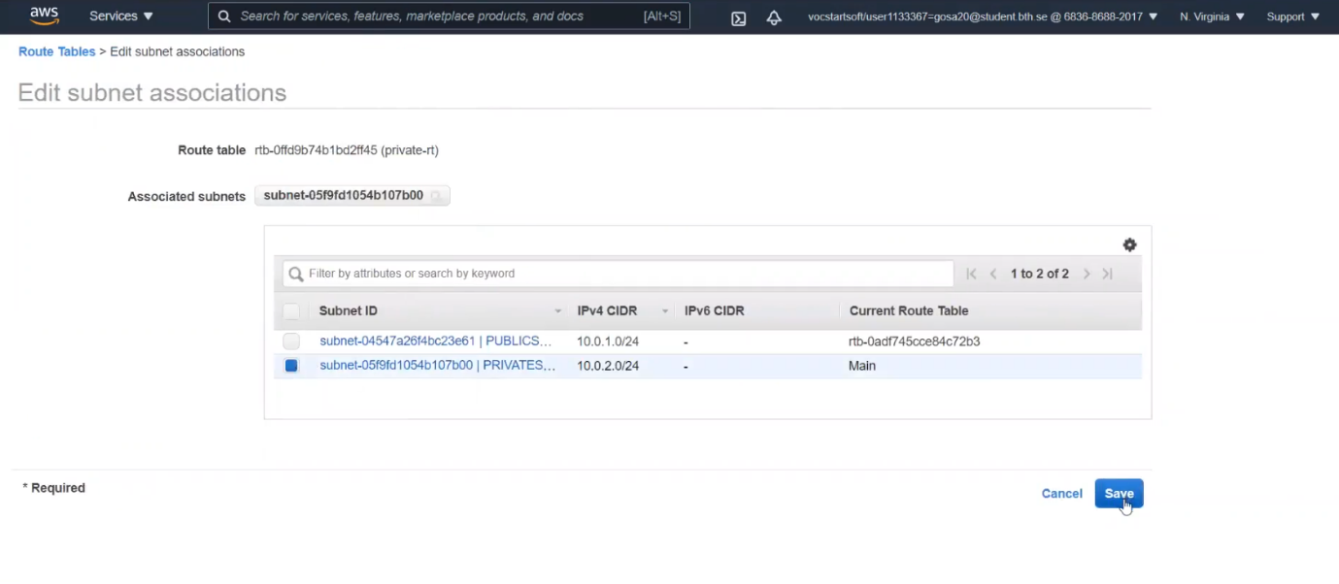

**Creating Virtual Machine and run it in the VPC:**

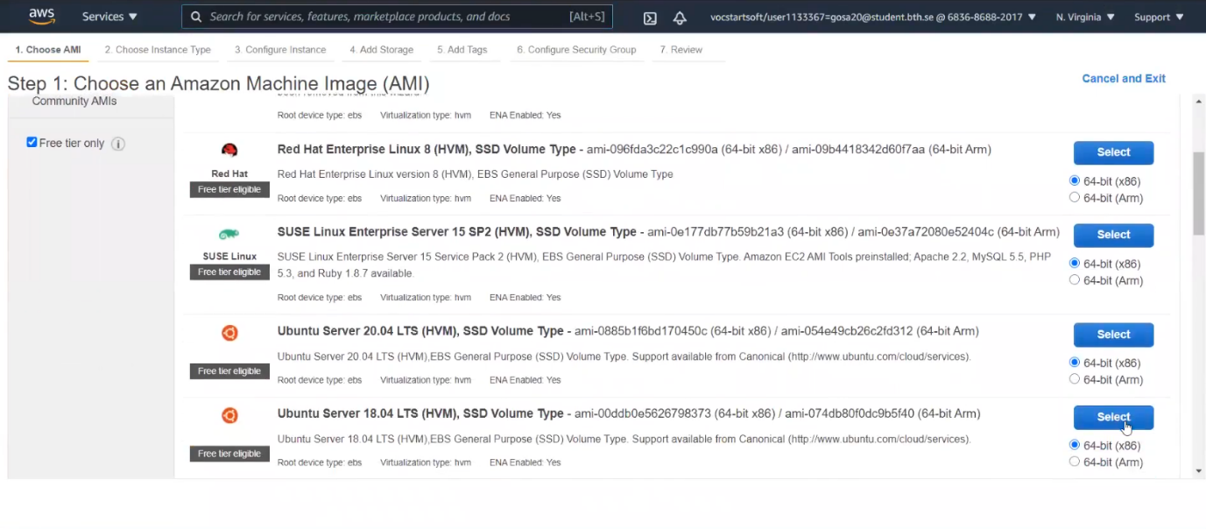

Choose and select the amazon machine images.

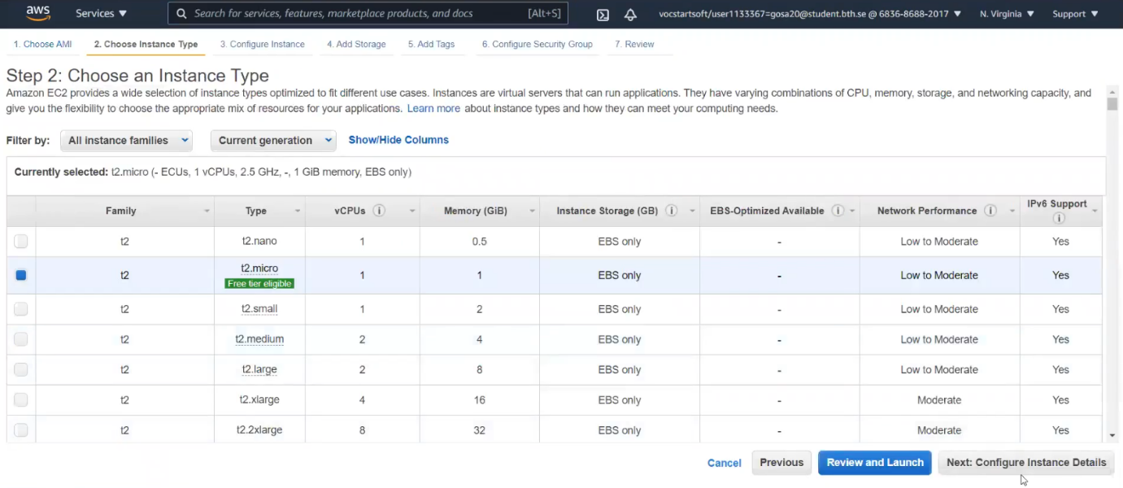

Select the t2micro instance type

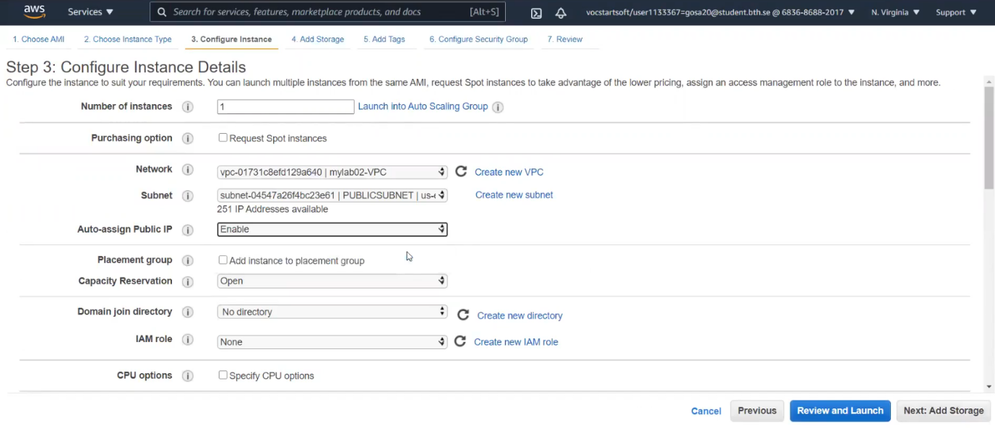

Select the created VPC and public subnet. Enable the auto assign public IP.

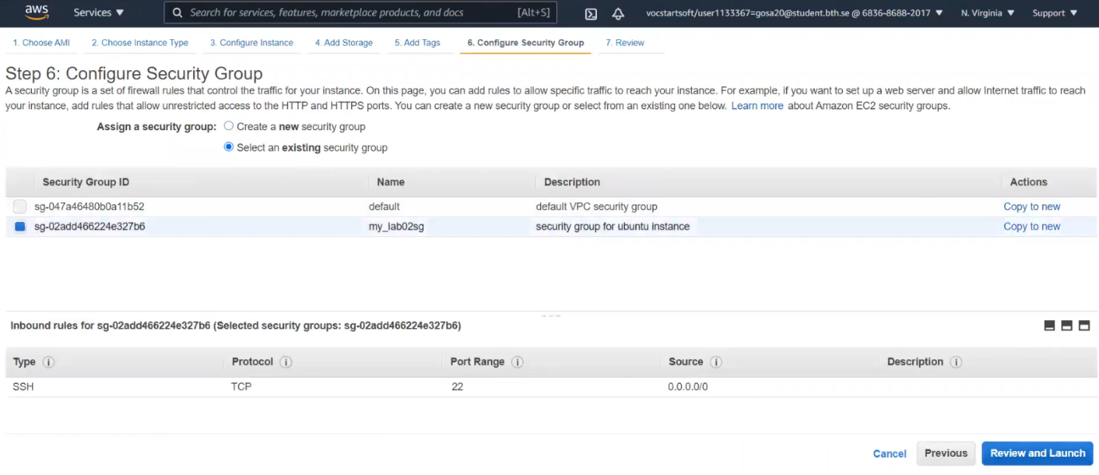

Now we select the existing security group as we created earlier.

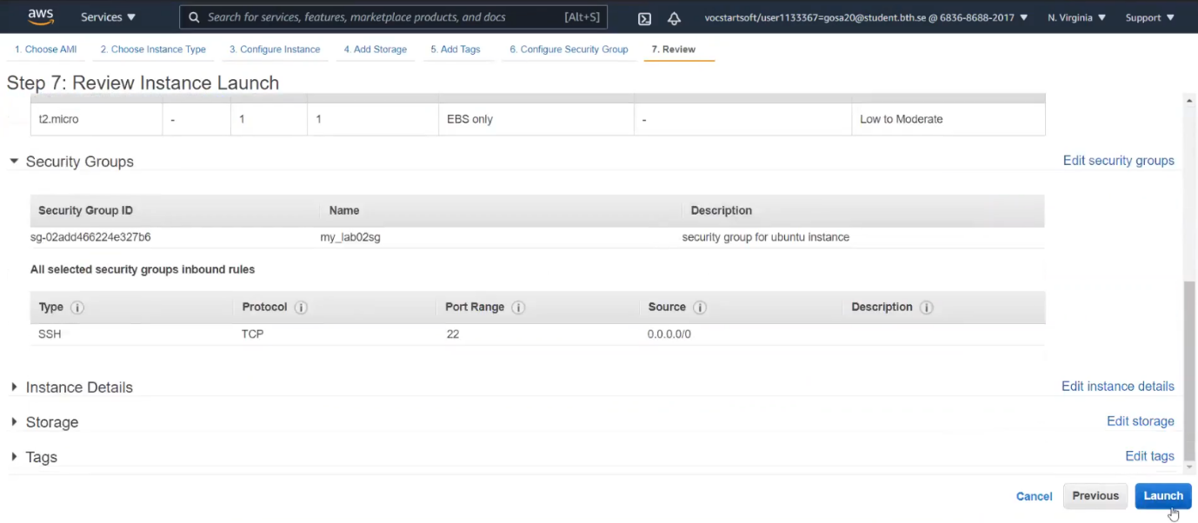

Review and launch the Instance.

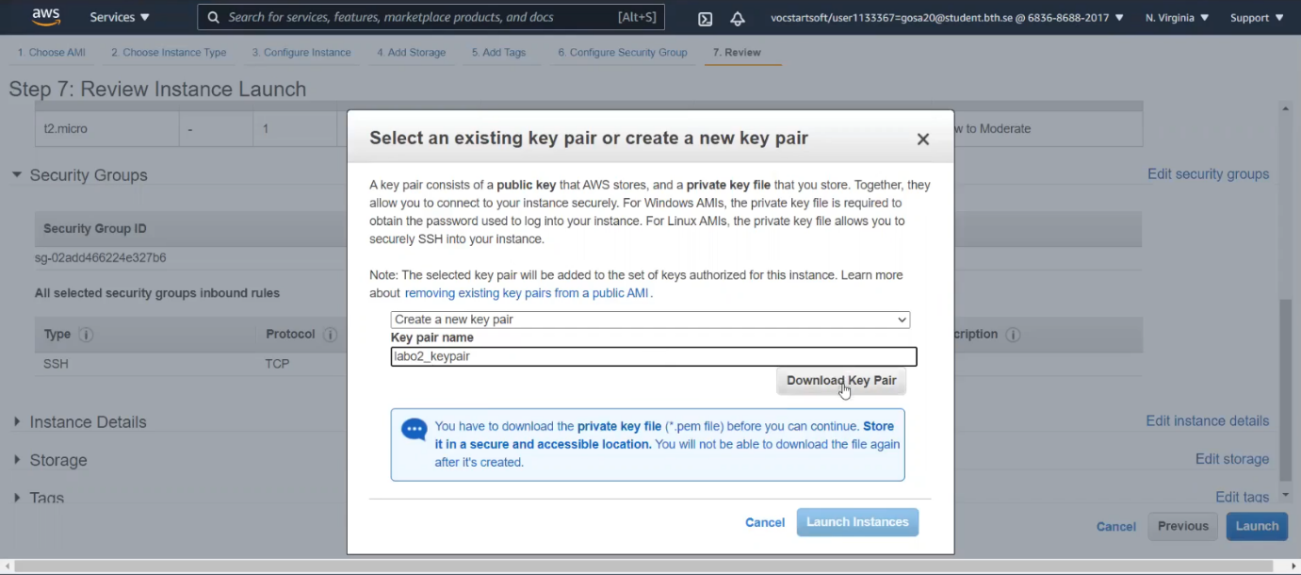

Create the key pair and download the keypair to access the VM.

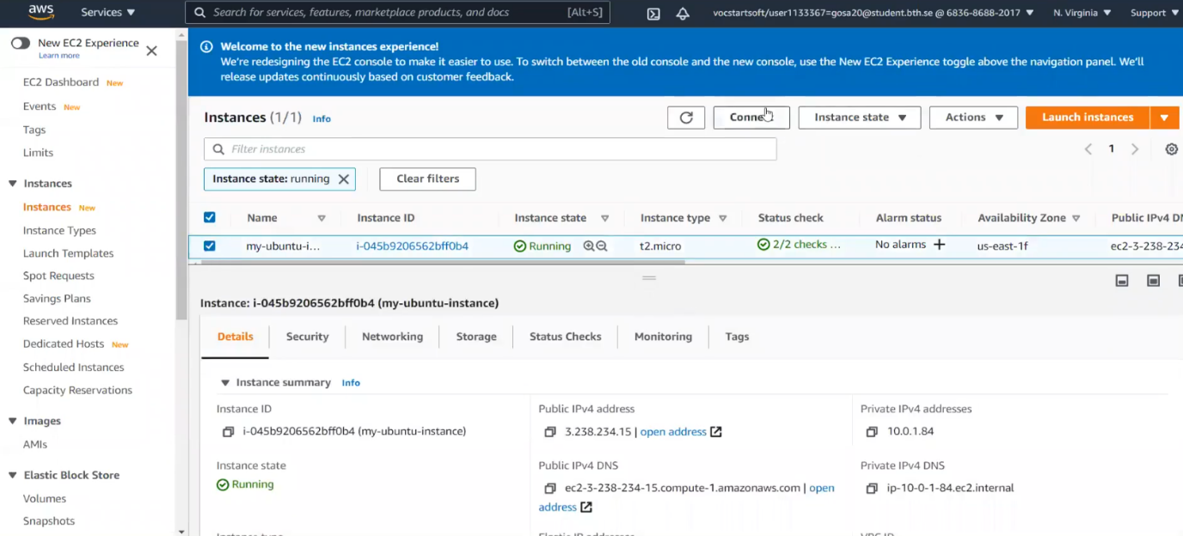

Now connect the Instance

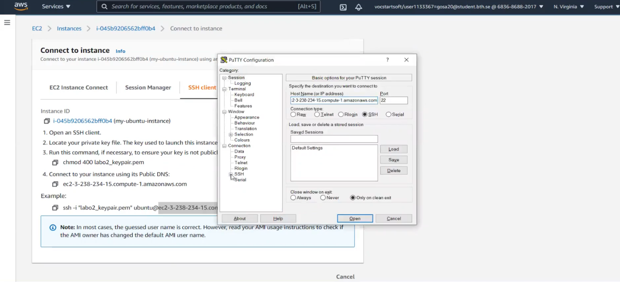

Now connect the instance using the public DNS.

We have to add our keypair file into Public Key Properties and add user “ubuntu” to login into CLI

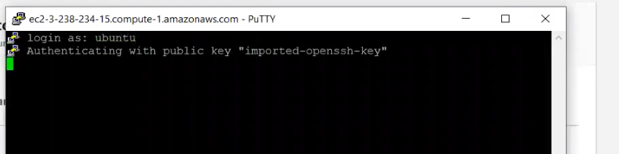

**Task2: Monitoring the performance of an EC2 instance while under CPU and disk pressure.**

Here we are selecting the ubuntu instance for this task

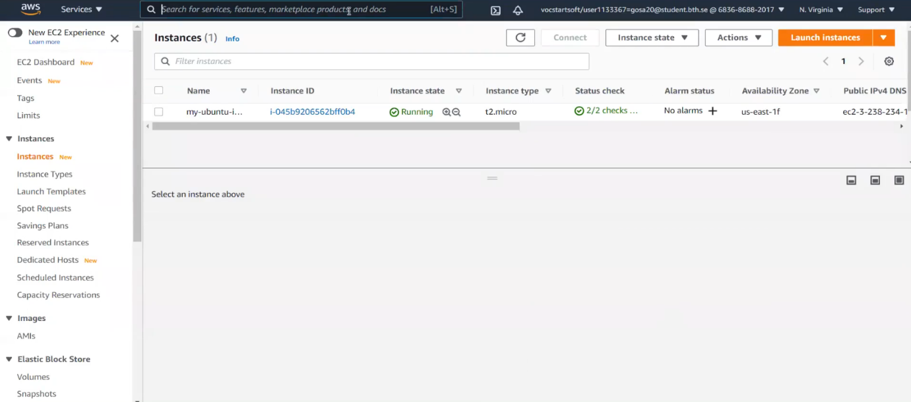

Creating a cloud watch dashboard “mylab02dashborad”.

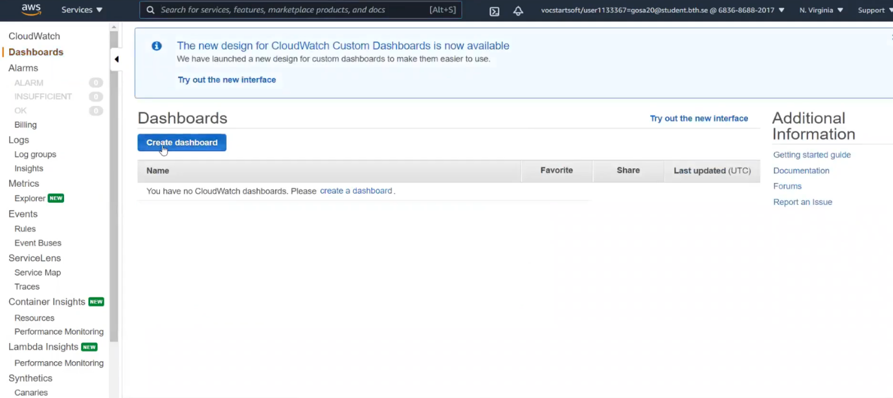

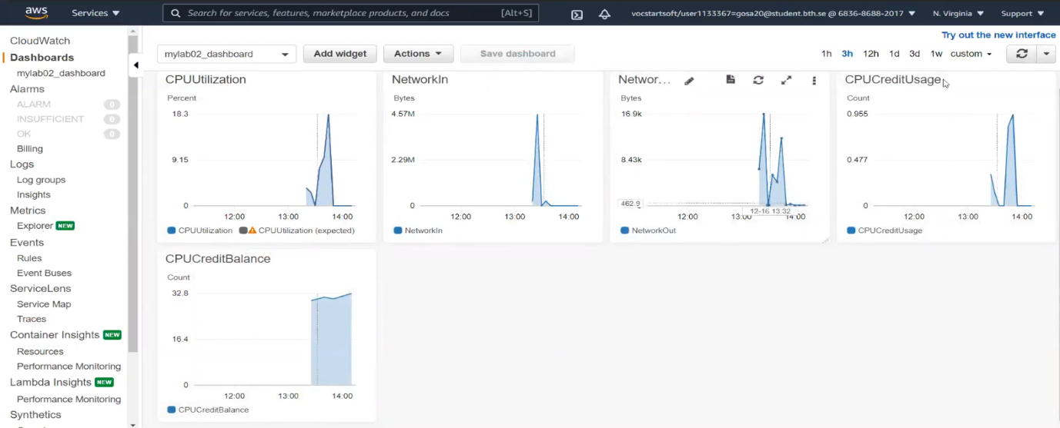

**What are the performance metrics selected and why (motivate your choices)**

We have taken CPU utilization, CPU credit usage, CPU credit balance, Network in, Network out metrics. These are selected to monitor the EC2 instance load on CPU and their network usage. All these metrics are available in cloud watch.

**How you generated the load?**

The load is generated by using following command.

CPU load generation command:

for each in 1 2 4 8 16 32 64; do sysbench --test=cpu --cpu-maxprime=200000 --num-threads=$each run; done

The allocated EC2 compute units percent are in use on the instance.The processing power is identified by this metric is used in running the application on the selected instance.

**The meaning of your results (why you get such results and what they mean?)**

The command and results are given below.

for each in 1 2 4 8 16 32 64; do sysbench --test=cpu --cpu-max-prime=200000 --num-threads=$each run; done

This command is run for 7 times. The CPU utilization load been increased upto 90 percent and more. CPU utilization increased in parallel with increased number of threads.

**After running the below command the CPU Stress test for 7 times:**

For each in 1 2 4 8 16 32 64; do sysbench --test=cpu --cpu-max-prime=200000 –numthreads =$each run; done

Here you can see once stress has been generated the CPU Utilization raise more than 90%.

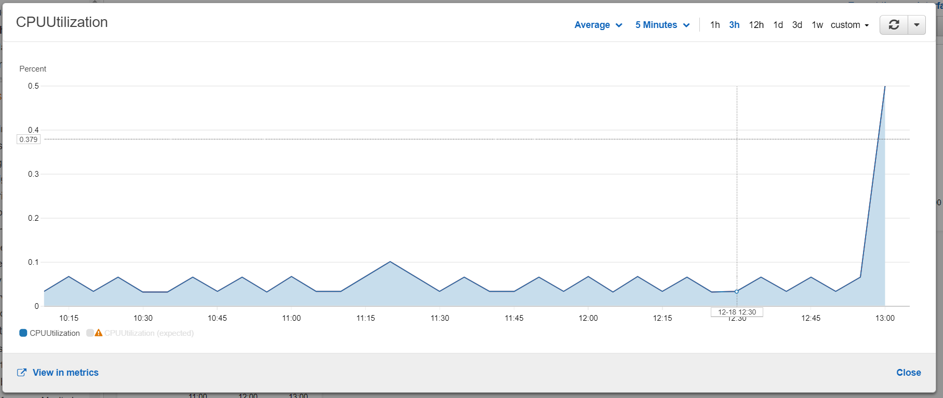

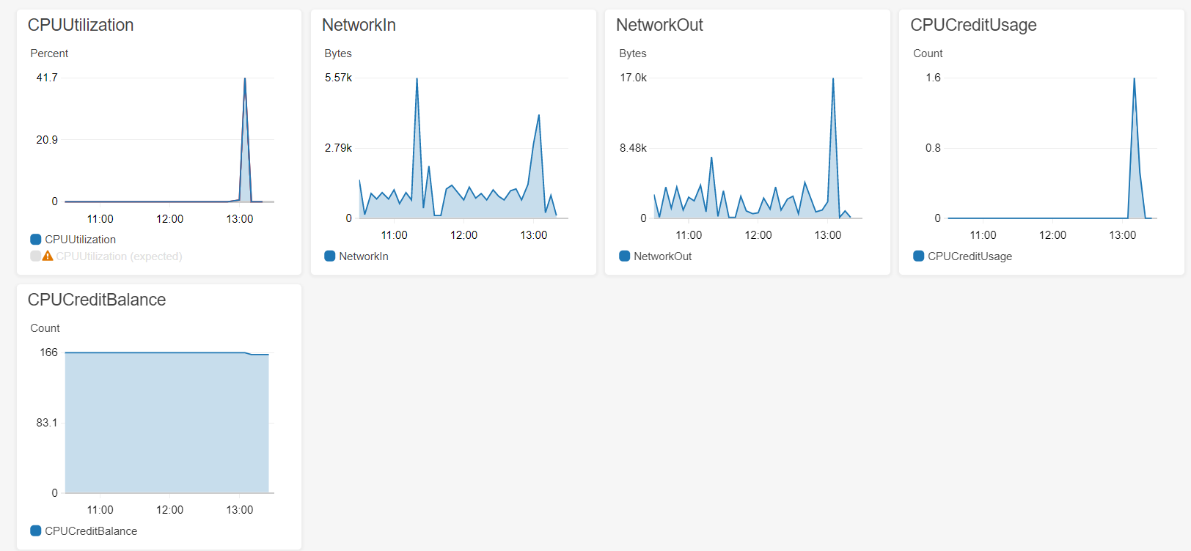

**After running the below command the CPU Utilization average result is:**

“sysbench --test=fileio --file-total-size=5G --file-num=4 prepare”

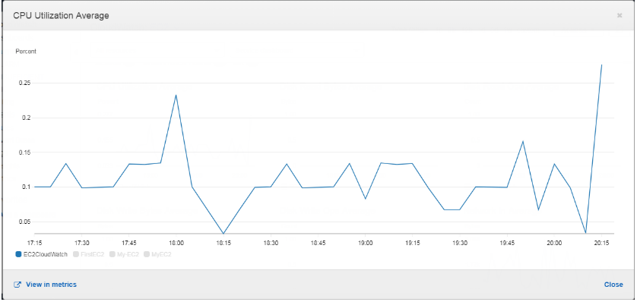

**After run below command the result of dashboard:**

“for each in 1 4 8 16 32; do sysbench --test=fileio --file-total-size=5G --file-test-mode=rndwr --maxtime=150 --max-requests=0 --file-block-size=4K --file-num=3 --num-threads=$each run; done;”

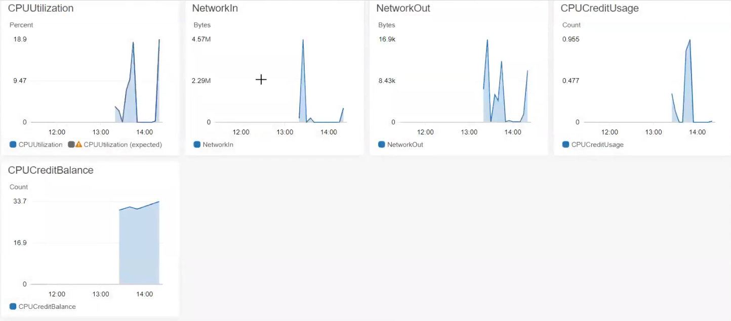

**Task-3: Communication**

**What are the performance metrics selected and why?**

We have selected ec2 performance metrics for amazon Linux virtual machine and installed apache server on that virtual machine.

**How you generated the load with apache bench?**

To do load tests on http server website apache bench or ab tool is used as command line tool. We have chosen apache bench as we have apache bench installed by default in the system.

Here we are using the two VMs that are my-ubuntu and Amazon Linux instances which are already created earlier.

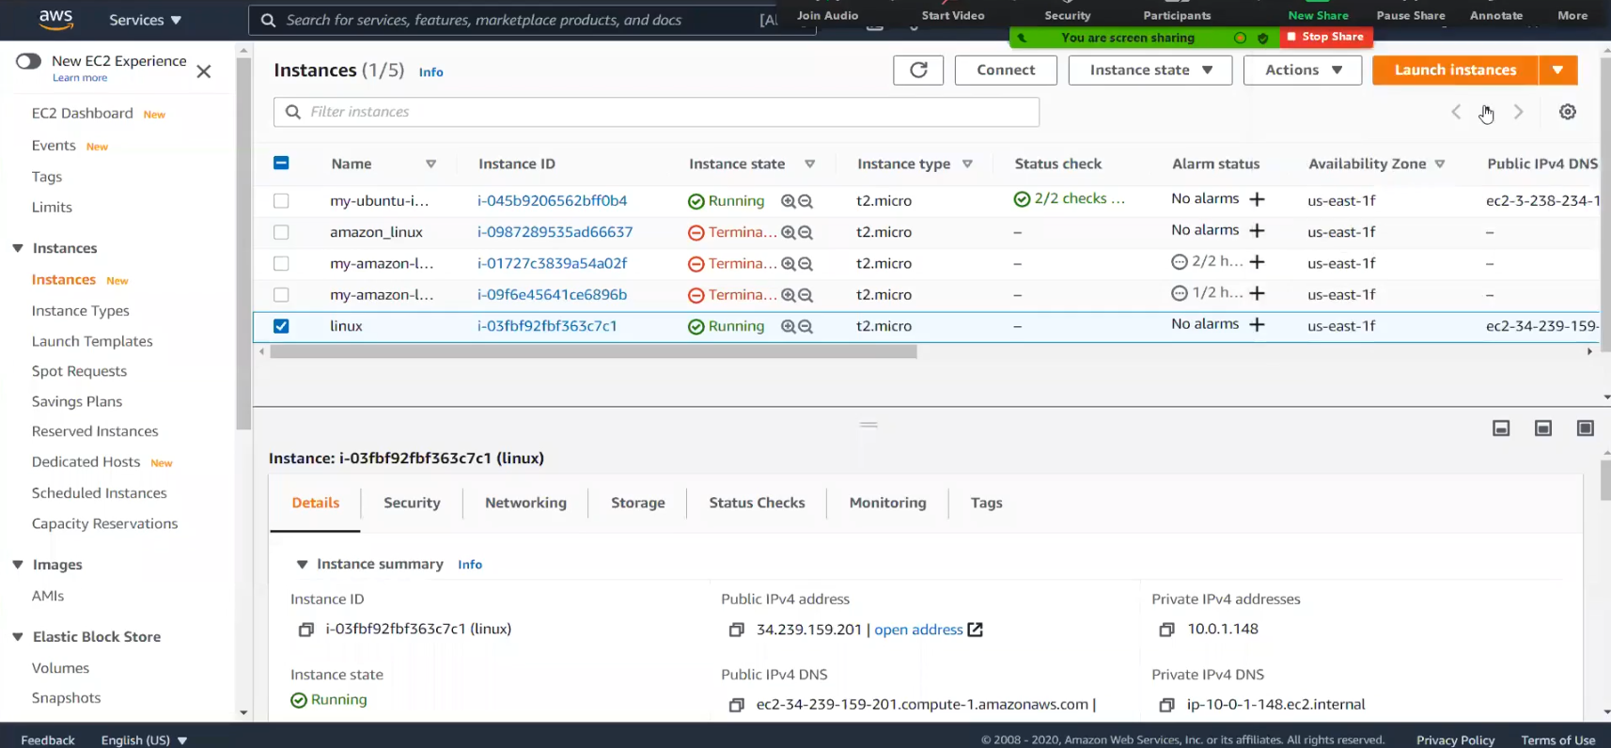

Here we should add Inbound rules in our security group

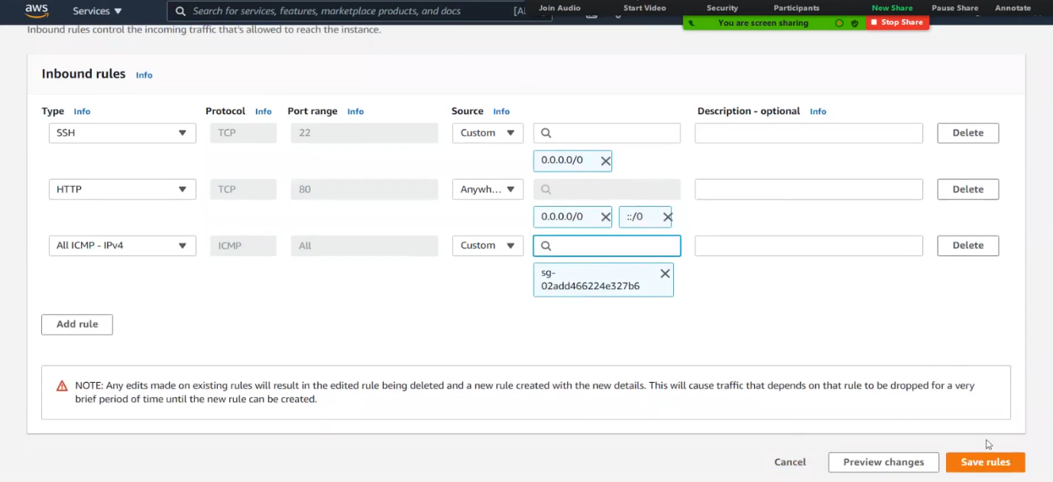

Here we have included HTTP and All ICMP-IPv4 type in Inbound rules of security group.

Now Apache installed in Amazon Linux (VM1):

1.sudo yum update -y

2.sudo yum install httpd -y

3.sudo service httpd status

4.sudo service httpd start

5.sudo service httpd status

By running the above commands the apache installed in our VM1.

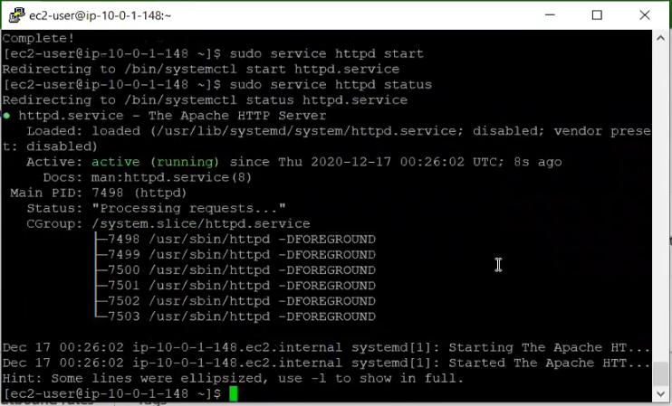

Now Apache2 utils installed in Ubuntu instance (VM2):

1.sudo apt-get update -y

2.sudo apt-get install apache2-utils

3.sudo systemctl start apache2

4.sudo systemctl status apache2

5.sudo systemctl stop apache2

By running the above commands the apache2-utils installed in our VM2.

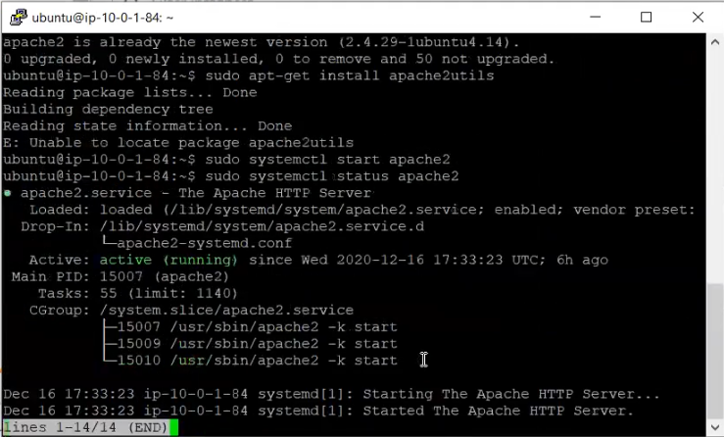

**Creating HTML webpage in the apache webserver in VM1:**

To create the HTML page in apache webserver the following commands are used:

1. To install apache and its dependencies the following command should run on the Linux terminal

**yum install httpd\***

1. To reach default web root directory create new directory

cd /var/www/html/

mkdir owndir

1. Go to the directory and edit the index.html

cd owndir/

vim index.html

HTML code:

<!DOCTYPE html>

<html>

<body>

<p><a href="https://www.google.com">Visit our google here</a></p>

</body>

</html>

1. Create another file to configure apache

vim /etc/httpd/conf.d/http.conf

<virtualhost *:80>

servername www.google.com

documentroot /var/www/html/owndir

</virtualhost>

<directory /var/www/html/owndir>

require all granted

</directory>

1. To know whether the selinux policy is configured or not.

ls -lZ /var/www/html/owndir/

1. Enable apache service

systemctl enable httpd.service

systemctl restart httpd.service

After running the above commands the HTML page is created in VM1:



Now, to connect two virtual machines we need to ping the IP address of one virtual machine in another virtual machine.

Now we ping the VM2 Ip address in VM1.

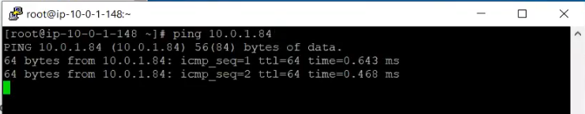

Now we ping the VM1 Ip address in VM2.

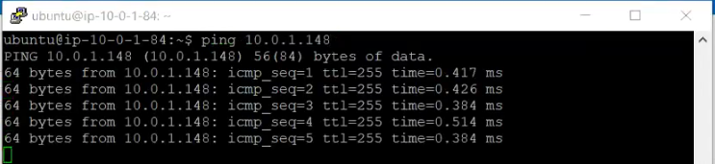

**The meaning of your results (why you get such results and what they mean?)**

We will produce pressure through Apache Bench with following orders and the outcomes are referenced under in detail. We have produced "150000" number of requests with number of "15" number of simultaneous clients to our objective page index.html. Kindly find under the details with screen captures.

After apache bench completes the HTTP requests, the output will look like this:

